SIMATS ENGINEERING

ASSESSMENT TOOL 3

COURSE CODE: CSA14 COURSE NAME: Compiler Design

COURSE OUTCOME COVERED

CO2: Construct top-down and bottom up parsers using CFG for parsing conflicts and error recovery for efficient syntax tree generation. (BL3)

Assessment Tool Weightage: 10%

Duration :60 Mins On Class
QUESTIONS: 50 Total Marks:50

Annexure A

Viva Voce

Code of Conduct:

I Tejaswi Reddy K(192371036) certify that this submission is my original work and that I have adhered to the guidelines specified for this assessment.
I understand that any violation of academic integrity rules will result in disciplinary action.

Signature of the student:

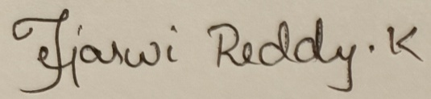

Annexure A

Viva Voce
Q1.What is syntax analysis?
Q2.Why is syntax analysis needed in a compiler? Q3.What is the role of a parser?
Q4.What is a Context-Free Grammar (CFG)?
Q5.What are the components of a Context-Free Grammar? Q6.What is a terminal symbol?
Q7.What is a non-terminal symbol? Q8.What is a production rule?
Q9.What is the start symbol in a grammar? Q10.What is derivation in Context-Free Grammar? Q11.What is leftmost derivation?
Q12.What is rightmost derivation? Q13.What is a parse tree?
Q14.What is the difference between a parse tree and a derivation? Q15.What is an ambiguous grammar?
Q16.How can ambiguity be removed from a grammar? Q17.What is left recursion?
Q18.Why should left recursion be eliminated? Q19.What is indirect left recursion?
Q20.What is left factoring? Q21.Why is left factoring required? Q22.What is Top-Down Parsing?
Q23.What are the advantages of Top-Down Parsing? Q24.What are the limitations of Top-Down Parsing? Q25.What is Recursive Descent Parsing?
Q26.What are the advantages of Recursive Descent Parsing? Q27.What are the limitations of Recursive Descent Parsing? Q28.What is backtracking in Recursive Descent Parsing?
Q29.What is Predictive Parsing?
Q30.Why is Predictive Parsing called an LL(1) parser? Q31.What is FIRST()?
Q32.What is FOLLOW()?
Q33.Why are FIRST and FOLLOW sets required?

Q34.What is a Predictive Parsing Table?
Q35.What are the conditions for constructing an LL(1) grammar? Q36.What is Bottom-Up Parsing?
Q37.What is Shift-Reduce Parsing?
Q38.What are the four actions of a Shift-Reduce Parser? Q39.What is a handle?
Q40.What is handle pruning?
Q41.What is Operator Precedence Parsing?
Q42.What are the advantages of Operator Precedence Parsing? Q43.What is an LR parser?
Q44.What are the advantages of LR parsing? Q45.What is an SLR parser?
Q46.What is an augmented grammar? Q47.What is a viable prefix?
Q48.What is syntax error recovery?
Q49.What are the common syntax error recovery techniques? Q50.What is YACC, and why is it used in compiler design
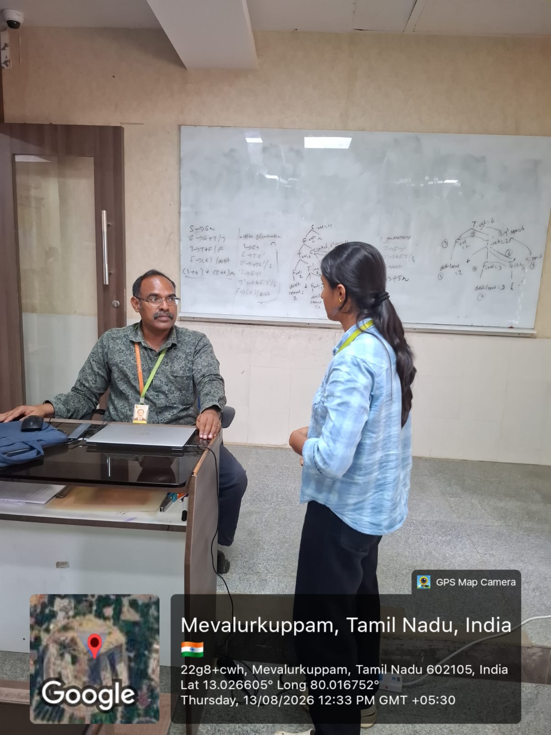

RUBRICS FOR CALCULATION:

Criteria | Weightage | Level 4 (Exemplary) | Level 3 (Proficient) | Level 2 (Developing) | Level 1 (Beginning)
Conceptual Understanding | 25 | Demonstrates deep understanding of concepts with complete clarity | Explains concepts correctly with minor gaps | Partial understanding with errors or omissions | Unable to explain basic concepts
Application | 25 | Effectively applies concepts to new  situations; solves problems logically | Applies concepts with minor errors | Limited ability to apply concepts; requires guidance | Unable to apply  concepts effectively
Analytical Thinking | 20 | Critically analyzes scenarios with  strong justification and reasoning | Provides reasonable  analysis with some justification | Superficial analysis with weak reasoning | No analytical reasoning demonstrated
Communicati on | 15 | Communicates ideas clearly, confidently, and with appropriate  terminology | Communicates clearly but with minor hesitation | Communication lacks clarity or structure | Unable to communicate ideas effectively
Response to Questions | 15 | Responds accurately and confidently,  extending answers with depth | Responds correctly but with limited depth | Responds partially; requires prompting | Unable to  respond to questions effectively

